**Quantum Logic Gates**

Quantum computers rely on qubits instead of classical bits. A classical bit can be either 0 or 1, while a qubit can exist in a superposition of both states simultaneously:

∣𝜓⟩ = 𝛼∣0⟩ + 𝛽∣1⟩, ∣𝛼∣2+∣𝛽∣2=1

This ability to exist in multiple states at once gives quantum computers their unique computational power.

However, qubits alone are not enough to perform quantum computations. Operations on qubits are performed using quantum logic gates, which are represented by unitary matrices. These gates manipulate the amplitudes and phases of qubits while preserving quantum probabilities.

Quantum gates fall into two main categories:

* **Single-qubit gates**: act on individual qubits.
* **Multi-qubit gates**: create entanglement by allowing qubits to interact.

**Single-Qubit Gates:**

1. **Hadamard Gate (H)**  
   Creates an equal superposition state:

H= $\frac{1}{\sqrt{2}}\left(\begin{matrix}1 & 1 \\ 1 & -1\end{matrix}\right)$

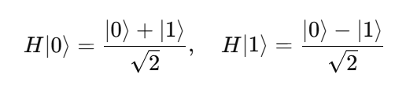

1. **Pauli-X Gate (X)** *(Bit flip)*

Bit-flip gate (classical NOT equivalent):

X= $\left(\begin{matrix}0 & 1 \\ 1 & 0\end{matrix}\right)$

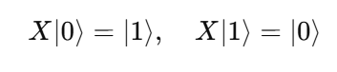

1. **Pauli-Y Gate (Y)** *(Rotation around Y-axis)*

90° rotation around the Y-axis:

Y= $\left(\begin{matrix}0 & -i \\ i & 0\end{matrix}\right)$



1. **Pauli-Z Gate (Z)** *(Phase flip)*

Phase-flip gate:

Z= $\left(\begin{matrix}1 & 0 \\ 0 & -1\end{matrix}\right)$



1. **Identity Gate (I)** *(No change)*

Leaves the qubit unchanged:

I= $\left(\begin{matrix}1 & 0 \\ 0 & 1\end{matrix}\right)$

1. **Phase Gate (S)** *(Phase shift of π/2)*

Adds a phase of $e^{i\frac{π}{2}}$

S= $\left(\begin{matrix}1 & 0 \\ 0 & i\end{matrix}\right)$

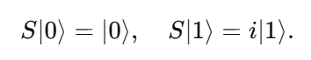

1. **T Gate (π/8 Gate)** *(Phase shift of π/4)*

Adds a phase of $e^{i\frac{π}{4}}$

(rotation of π/4 radians around the Z axis)

T= $\left(\begin{matrix}1 & 0 \\ 0 & e^{i\frac{π}{4}}\end{matrix}\right)$

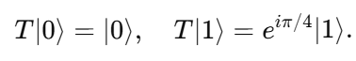

1. **Rotation Gates (Rx, Ry, Rz)**

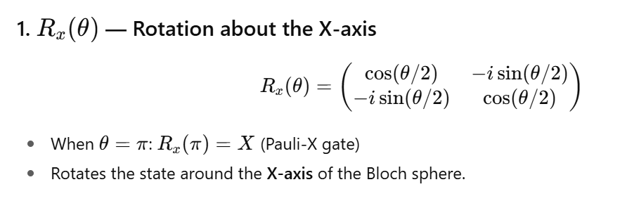

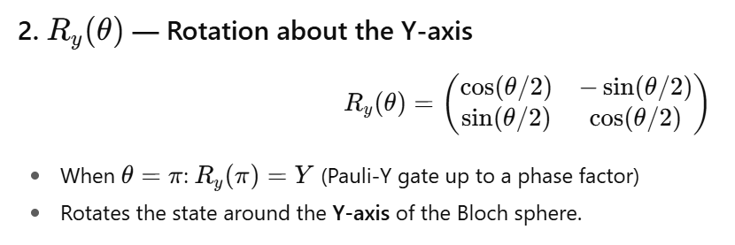

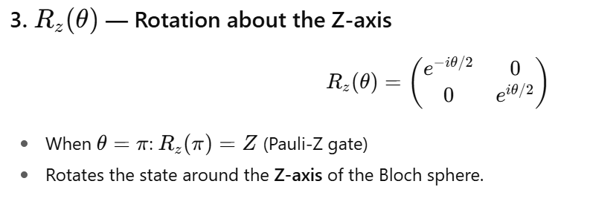

**Multi-Qubit Gates:**

1. **Controlled-NOT Gate (CNOT) *(Control: first qubit, Target: second qubit)***

Flips the target qubit if the control qubit is ∣1⟩.

$$CNOT=\left(\begin{matrix}\begin{matrix}1 \\ 0\end{matrix} & \begin{matrix}0 & \begin{matrix}0 & 0\end{matrix} \\ 1 & \begin{matrix}0 & 0\end{matrix}\end{matrix} \\ \begin{matrix}0 \\ 0\end{matrix} & \begin{matrix}0 & \begin{matrix}0 & 1\end{matrix} \\ 0 & \begin{matrix}1 & 0\end{matrix}\end{matrix}\end{matrix}\right)$$

1. **Controlled-Z Gate (CZ)**

Applies a phase flip if the control qubit is ∣1⟩.

$$CZ=\left(\begin{matrix}\begin{matrix}1 \\ 0\end{matrix} & \begin{matrix}0 & \begin{matrix}0 & 0\end{matrix} \\ 1 & \begin{matrix}0 & 0\end{matrix}\end{matrix} \\ \begin{matrix}0 \\ 0\end{matrix} & \begin{matrix}0 & \begin{matrix}1 & 0\end{matrix} \\ 0 & \begin{matrix}0 & -1\end{matrix}\end{matrix}\end{matrix}\right)$$

1. **SWAP Gate**

Swaps the quantum states of two qubits.

$$SWAP=\left(\begin{matrix}\begin{matrix}1 \\ 0\end{matrix} & \begin{matrix}0 & \begin{matrix}0 & 0\end{matrix} \\ 0 & \begin{matrix}1 & 0\end{matrix}\end{matrix} \\ \begin{matrix}0 \\ 0\end{matrix} & \begin{matrix}1 & \begin{matrix}0 & 0\end{matrix} \\ 0 & \begin{matrix}0 & 1\end{matrix}\end{matrix}\end{matrix}\right)$$

1. **Toffoli Gate (CCNOT) *(Control: first two qubits, Target: third qubit)***

Three-qubit gate; flips the target qubit if both control qubits are ∣1⟩.

$$CCNOT(Tiffoli)=\left(\begin{matrix}\begin{matrix}\begin{matrix}1 & 0 \\ 0 & 1\end{matrix} & \begin{matrix}0 & 0 \\ 0 & 0\end{matrix} \\ \begin{matrix}0 & 0 \\ 0 & 0\end{matrix} & \begin{matrix}1 & 0 \\ 0 & 1\end{matrix}\end{matrix} & \begin{matrix}\begin{matrix}0 & 0 \\ 0 & 0\end{matrix} & \begin{matrix}0 & 0 \\ 0 & 0\end{matrix} \\ \begin{matrix}0 & 0 \\ 0 & 0\end{matrix} & \begin{matrix}0 & 0 \\ 0 & 0\end{matrix}\end{matrix} \\ \begin{matrix}\begin{matrix}0 & 0 \\ 0 & 0\end{matrix} & \begin{matrix}0 & 0 \\ 0 & 0\end{matrix} \\ \begin{matrix}0 & 0 \\ 0 & 0\end{matrix} & \begin{matrix}0 & 0 \\ 0 & 0\end{matrix}\end{matrix} & \begin{matrix}\begin{matrix}1 & 0 \\ 0 & 1\end{matrix} & \begin{matrix}0 & 0 \\ 0 & 0\end{matrix} \\ \begin{matrix}0 & 0 \\ 0 & 0\end{matrix} & \begin{matrix}0 & 1 \\ 1 & 0\end{matrix}\end{matrix}\end{matrix}\right)$$

1. **Controlled-Phase Gate (CPHASE) *(phase shift ϕ)***

Adds a phase depending on the control qubit’s state.

$$CPHASE(Φ)=\left(\begin{matrix}\begin{matrix}1 \\ 0\end{matrix} & \begin{matrix}0 & \begin{matrix}0 & 0\end{matrix} \\ 1 & \begin{matrix}0 & 0\end{matrix}\end{matrix} \\ \begin{matrix}0 \\ 0\end{matrix} & \begin{matrix}0 & \begin{matrix}1 & 0\end{matrix} \\ 0 & \begin{matrix}0 & e^{iΦ}\end{matrix}\end{matrix}\end{matrix}\right)$$

1. **Fredkin Gate (CSWAP) *(Control: first qubit, Swap: second and third)***

Swaps two target qubits if the control qubit is ∣1⟩.

$$Fredkin=\left(\begin{matrix}\begin{matrix}\begin{matrix}1 & 0 \\ 0 & 1\end{matrix} & \begin{matrix}0 & 0 \\ 0 & 0\end{matrix} \\ \begin{matrix}0 & 0 \\ 0 & 0\end{matrix} & \begin{matrix}1 & 0 \\ 0 & 1\end{matrix}\end{matrix} & \begin{matrix}\begin{matrix}0 & 0 \\ 0 & 0\end{matrix} & \begin{matrix}0 & 0 \\ 0 & 0\end{matrix} \\ \begin{matrix}0 & 0 \\ 0 & 0\end{matrix} & \begin{matrix}0 & 0 \\ 0 & 0\end{matrix}\end{matrix} \\ \begin{matrix}\begin{matrix}0 & 0 \\ 0 & 0\end{matrix} & \begin{matrix}0 & 0 \\ 0 & 0\end{matrix} \\ \begin{matrix}0 & 0 \\ 0 & 0\end{matrix} & \begin{matrix}0 & 0 \\ 0 & 0\end{matrix}\end{matrix} & \begin{matrix}\begin{matrix}1 & 0 \\ 0 & 0\end{matrix} & \begin{matrix}0 & 0 \\ 1 & 0\end{matrix} \\ \begin{matrix}0 & 1 \\ 0 & 0\end{matrix} & \begin{matrix}0 & 0 \\ 0 & 1\end{matrix}\end{matrix}\end{matrix}\right)$$

**Other Useful Gates and Constructs**

* **Bell State Creation**: Combine H and CNOT to generate entangled Bell pairs.

Apply H on first qubit → apply CNOT → produces $\frac{∣00⟩+∣11⟩ }{\sqrt{2}}$

* **Grover’s Oracle**: Marks correct solutions in Grover’s search algorithm via a phase flip.

Implemented with a phase flip conditioned on the solution state.

* **Quantum Fourier Transform (QFT)**: A sequence of gates performing the Fourier transform in quantum algorithms such as Shor’s factoring algorithm.

Built from Hadamard and controlled-phase gates.

* **Quantum Swap Test**: Used to compare quantum states by measuring their overlap.

Uses a controlled-SWAP gate to measure overlap between two quantum states.